Jewell Jubilee
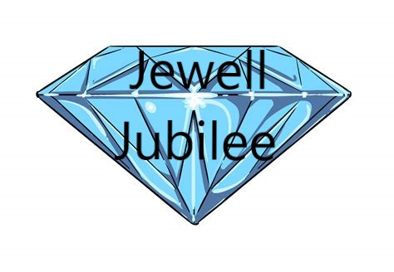
2nd Annual Smoked Meats Competition
Pork Loin and Ribs
Saturday, June 15th, 2019

Name: _______________________________
Phone Number: ______________________________
Email Address: _______________________________

- $25 Entry Fee Per Team
- Meats will be provided. 1 Pork loin and 1 Baby back rib.
- Teams will pick up meat Saturday June 15th at 8am at the Park.
- Entry must be plated and at Judges table by 6pm
- Entry Deadline June 7th
- WINNERS will get a new set of Grill Utensils

Please make checks payable to Jewell Jubilee
You can drop off Entry Form and Fee at Jewell city hall or mail to this address.
Chris Austin
312 Main St
Jewell, Iowa 50130

